**Cognitive and brain morphological deviations in middle-to-old, aged autistics adults**

“This is my own work. I have not copied any of it from anyone else.”

**November 2024**

**Michael Le 21689299**

**Introduction**

I have reviewed and extended meta-analysis by J. Wang et al, published in the journal Neuroscience and Biobehavioral Reviews. It includes 30 independent observations from three different categories on cognitive domain, on 3608 records on middle to old aged autistic adults under different ranges of sub studies conditions and cross-sectional designs.

Among different types of participant information, cognitive assessments and summarized findings for cognitive study outcomes are categorized into ‘cognitive domains. It is crucial to confirm ASD diagnostics examined carefully whether incoming and recurring participants has been maintained diagnostic stability over time include increased retention rates. The main pre-specified objective performing this meta-analysis is to measure cognitive ability and brain structure deviations in middle-to-old aged autistic adults individuals and neurotypical controls.

The claimed key findings from existing claims that autistic adults’ manifest deviations in cognitive and brain domains associated with neurotypical controls, and that direct implications they are more vulnerable to early cognitive impairments or pathological aging associated conditions compared to neurotypical controls. The suggested implications that should be taken consideration to enhanced further by their cognitive process and assessments to determine based on their cognitive ability and stability over time.

**Methods**

The authors provide a quality assessment of selected articles for Cognitive dysfunctions and brain morphological changes in middle-to-old aged autistic adults: A systematic review and meta-analysis **[2]** statement; details further implications and conventions on cognitive changes and structural brain changes are included.

The outcome of interest was assessing aging-related cognitive and/or brain variations were assessed by three different categories of cognitive domains, global cognitive function, executive function and episodic memory were applied for this analysis, reported as estimated Standardised Mean Differences (SMDs) in Cognitive deviations in middle to old aged autistic adults. The authors report the SMDs were estimated using Hedge’s g represents the effect size derived from the meta-analysis. A positive Hedges’ g indicated that the control group had a better performance than the autistic group **[1].** These estimates and their associated 95% Confidence Intervals (CIs) were calculated using R a statistical software programming language is practical for creating meta-analysis and regressions, despite it has not been mentioned on paper**.** It can allow to perform; meta-analytic estimates and forest plots were produced taken Random Effects Model (REM) was used in the paper during the analysis.

Aside from the overall estimate from all 30 interventions, 3 subgroup analyses (A, B and C) were conducted on cognitive domain. The following studies were partitioned by: (A) global cognitive function compressed into one stage; (B) executive function, and (C) episodic memory are both compressed into two stages.

The authors report using Egger’s Q test to assess the evidence of between-subgroup differences for different cognitive domains in true SMDs. Risk of publication bias was assessed from the Supplementary Figures 5 contains two figures (A) including studies that used MMSE as a screening tool and (B) excluding studies that used MMSE as a screening tool to conclude the tests were not significant. For Supplementary Figure 6 contains our figures (A) executive function, (B) cognitive processes of flexibility, planning (C) and working memory (D) where (A) Egger’s test was the only group demonstrating statistical significance. Lastly for Supplementary Figure 7 contains three figures containing episodic memory (A), cognitive process of verbal (B) and visual memory (C) where all tests were not significant: A funnel plot of all 30 observations was produced, similarly for Egger’s test for funnel plot asymmetry was conducted **[2].**

**Main findings**

Note that the positive values of the Hedges test of the SMD indicates that neurotypical controls had a better performance than autistic adults, determining cognitive ability and aging from different cognitive groups. Assuming that all significant levels were predetermined at 5% for each number of studies. The authors state that the overall observations were associated for each sub-group determines where neurotypical controls had better performance than autistic adults. For global cognitive function (A) (mean SMD = 0.505, 95% CI = [-0.404, 1.414]). For executive function (B) (mean SMD = 0.257, 95% CI = [0.031, 0.482]). For Episodic memory (C) (mean SMD = 0.145, 95% CI = [-0.068, 0.357]). Note that the diverse range of study conditions and approaches to intervention suggests that we should reasonably expect some heterogeneity to be present; and this has implications for our interpretation of the mean SMD. The main findings for subgroup analyses (A) during the cognitive process, (B) and (C) compressed into two stages (cognitive processes and assessments) as follows:

(A)

The estimated mean SMD for test for CFQ was small and significant (mean SMD = 1.365, 95% CI = [1.059, 1.670]); while that for MMSE, MoCA was big and not significant (mean SMD = -0.096, 95% CI = [-0.345, 0.152])) and (mean SMD = 0.251, 95% CI = [-0.103,0.605]))) were not sensitive**.** The CFQ exhibited a large effect size (SMD = 1.364, 95 % CI = 1.109 – 1.619, p < 0.001) compared to MoCA (SMD = 0.238, 95 % CI = [−0.072 ,0.548), p = 0.132) **[2]** (Supplementary Figure 2) observations. There is high significant heterogeneity in effect sizes was present among observations (I^2 = 92.687%), although publication bias was not significant **[2]** (Supplementary Figure 5) where the funnel plot does not any significance for asymmetry.

(B)

During the cognitive process, the estimated mean SMD for test for Working memory was significant (SMD = 0.339, 95% CI = [0.013,0.666]) cognitive process in identifying executive control deviations in middle-to-old aged autistic adults; while Flexibility/set-shifting was not significant (SMD = 0.313, 95% CI = [-0.073, 0.700]) similarity for planning (SMD = 0.057, 95% CI = [-0.365,0.480]. There is a moderate heterogeneity for multiple cognitive processes from four imputed studies (I^2 = 51.483%) contributed to removing publication bias was significant **[2]** (Supplementary Figure 6A) where the funnel plot shows signs of asymmetry where (Figure 6B, 6C and 6D) **[2]** does not show.

For the assessment stage for flexibility/set-shifting there are two trail marking tests for the Trail Marking test (SMD=0.615, 95% CI = [0.031,1.200]) was significant, Card Sorting Tasks (SMD = 0.615, 95% CI = [0.031,1.200]) was not significant. There is a high significant heterogeneity (I^2 = 67.689%) where publication bias was non-significant **[2]** (Supplementary Figure 6B). For Planning contains two different tasks, Assessing Tower tasks and BARD Zoo Map test with the estimated mean SMD test (SMD = 0.228, 95% CI = [-0.218,0.674]) and test (SMD=-0.073, 95% CI = [-0.598,0.451]) were both tests are not significant. Conclude, there is a large heterogeneity (I^2 = 62.040%) having no publication bias. For working memory, the WMS assessments were more effective (SMD = 0.835, 95 % CI = [0.434,1.236], p < 0.001) than WAIS tests (SMD= 0.244, 95 % CI = [−0.030,0.517], p = 0.081; **[2]** Supplementary Figure 3) was small and significant. There is a moderate heterogeneity (I^2 = 33.352%) leads to publication bias was non-significant.

(C)

During the cognitive process, the estimated SMD for verbal and visual are not significant given (SMD = 0.172, 95% CI = [-0.114,0.459]) and (SMD=0.111, 95% CI = [-0.204,0.427]) respectively where both values are big and insignificant. There is a high heterogeneity (I^2=58.727%) that publication bias was non-significant. For the assessment phase, on verbal and visual respectively (immediate recall: SMD = 0.172, 95% CI = [− 0.189, 0.533]; delayed recall: SMD = 0.091, 95% CI = [− 0.307,0.490]; recognition: SMD = 0.130, 95% CI =[ − 0.588 , 0.328]; **[2]** or visual (immediate recall: SMD = − 0.043, 95% CI =[ −0.368,0.281]; delayed recall: SMD = 0.033, 95 % CI = [− 0.291,0.357]; recognition: SMD = − 0.093, 95% CI = [− 0.506, 0.320]; **[2]** Supplementary Figure 4). There is a high heterogeneity for verbal memory (I^2 = 69.338 %) but moderate for visual memory (I^2 = 48.335%). All cases for publication bias were non-significant; **[2]** Supplementary Figure 7A, B and C) and visual memory **[2]** suggest that there is insignificant evidence for asymmetry.

**Replication of main findings**

For the i-th observation, the 95% confidence interval CI(i) used for the true SMD and Standard Error formulas below:

$$CI\left(\dot{ⅈ}\right)=D\left(ⅈ\right)± φ^{-1}\left(0.975\right)*SE(D\left(i\right))$$

$SE_{D\left(ⅈ\right)}^{2}$ = $\frac{\left(ⅆ_{i}-C_{L}^{\left(i\right)}\right)+\left(C_{u}^{\left(i\right)}-ⅆ_{i}\right)}{2ϕ^{-1}\left(0.975\right)}=\frac{C_{u}^{\left(i\right)}-C_{L}^{\left(i\right)}}{2ϕ^{-1}\left(0.975\right)}$

Assuming it follows under a standard normal cdf distribution, where D(i) is the observation estimator of the true SMD, and standard error $SE(D\left(i\right))$. In addition, $CL\left(i\right)$ and $CU\left(i\right)$ represent lower and upper limits for the confidence interval. Containing all meta-estimated SMDs, associated confidence intervals and I^2 values this can be achieved by applying similar meta-analysis methods such as the metafor package in R to determine the study effects using Hedges estimator ${\hat{τ}}_{HE}^{2}$, between study variances **[4]** assuming they are equal and inverse variance weights, thus, we use SMD. Associated I^2 statistic using the rma function; where the ith observation of the argument **vi** was set to $SE_{D\left(ⅈ\right)}^{2}$,and that ***yi***is equal to ***d(i)***. Using the funnel plot and Egger’s test p-value were executed using funnel and regression test. To observe comparisons of each of the study weights demonstrated with the observations reported rough estimates during the 4th Quiz given the standard error as rough method to perform these metrics to test out any significance for different cognitive domains for autistic adults. It was unclear which command was used to provide 95% CIs for I^2 under random effects model, this can be achieved manually using only the metafor package to match from the paper. In all relevant tests from all unique cognitive groups and studies the significance level was prespecified at 5%, see figures 1,2 and 3 below.

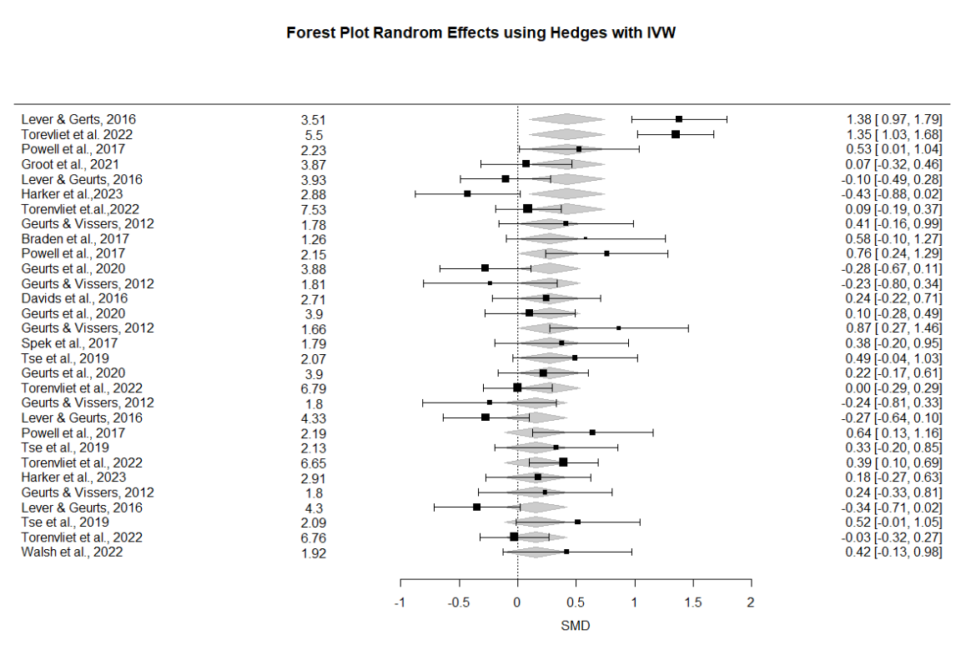

**Figure 1. Forest Plot Random Effects using Hedges estimator, using forest function for 30 observations produced using the metafor package.**

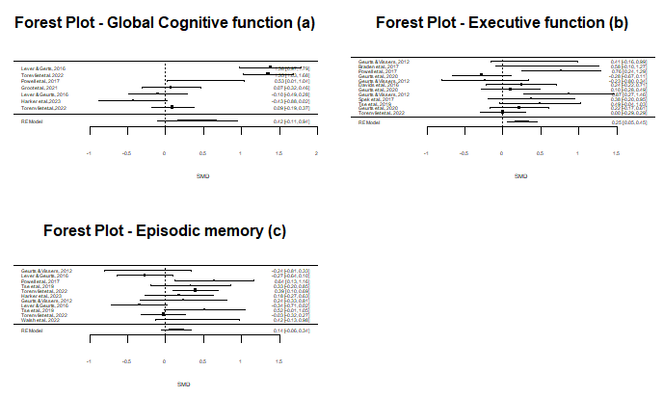**Figure 2. Forest Plot Random Effects using Hedges estimator, using forest function for different cognitive domains.**

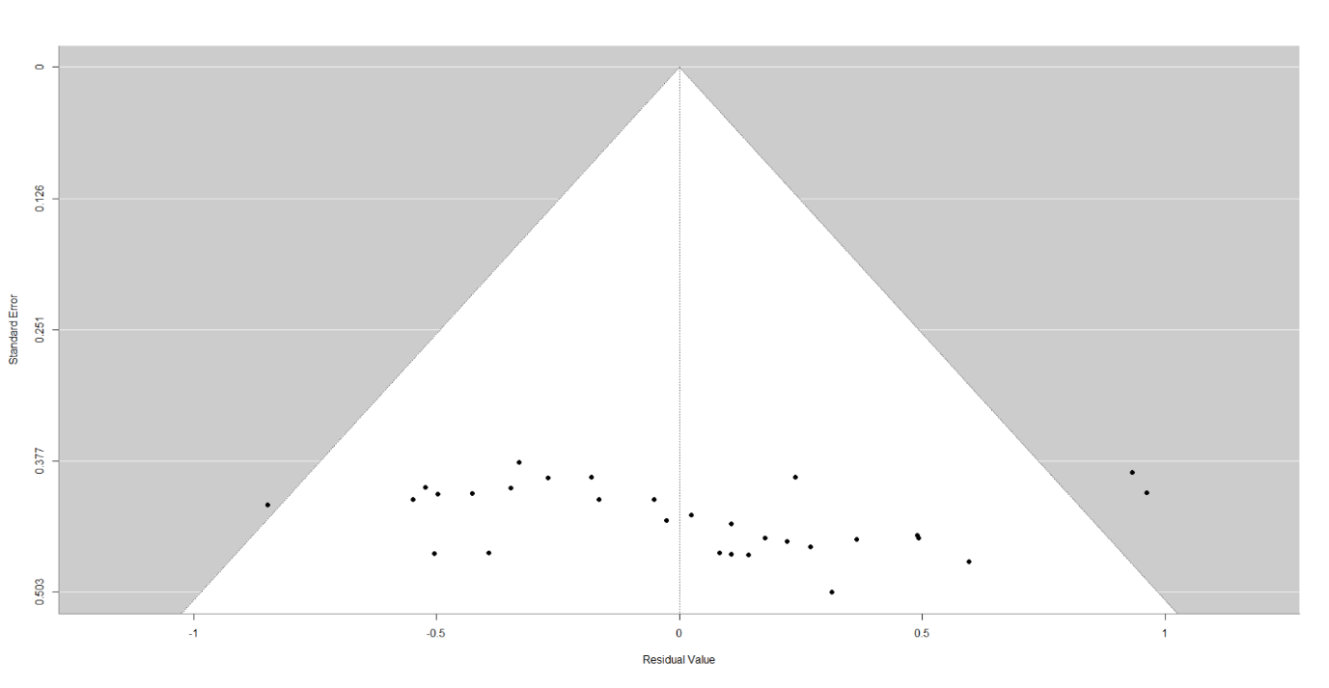

**Figure 3. Funnel Plot for all 30 observations.**

(Egger’s test for funnel plot asymmetry: z = 1.4209, p=0.1553)

**Limitations**

Limitations for SMD is used compared to MD (mean differences), allows results on different scales. Recall that SMD assumes on equal variances on neurotypical controls had a better performance than autistic adults for each observation share common variances. For example, taken account or assume that fact that observations differ from cognitive domains during each stage. The authors note that out of the 30 observations there are 22 observations are assessed for eligibility are included (15 were included in the review, 7 were expert opinion) **[2].** There are few observations on cognitive and structural brain changes in middle-to-old aged autistic adults. Primarily focusing on autistic adults without intellectual disability and dementia compared to typical controls. In addition, there are interferences related to aging-related cognitive and brain changes that can be quantified through inter-individual variations at baseline. Only three observations were assed either through longitudinal or mixed designs for middle-to-old, aged autistic adults to determine the decline of cognitive ability as aging becomes a problem **[1]**. This was likely due to inappropriate meta-analyses can either lead to false negative or results from small observations **[5]** that could lead to Heterogeneity of study results and metabias. Another limitation was considering demographic covariates such as age, sex, IQ, ASD severity, clinical comorbidities and long-term medication effect). Where recent studies (Pagni et al., 2022; McQuaid et al., 2023; Harker et al., 2023; Torenvliet et al., 2024) are confounding variables are the reason the increase of heterogeneity in the meta-analysis through different cognitive domains. However, (Higgins et al., 2020) study does not have enough observations available to determine factors that slowly or accelerate pathological aging. Overall, we should avoid interpreting an insignificant test result as evidence against publication bias can be challenging to re-examine the observations thoroughly from Supplementary Document **[2]** that have meet the criteria.

**Extensions**

It is worth investigating other estimators than Hedges as our only model as a limitation for the random effects model. After applying the replication of main findings during the analysis. Proper examples that can be appliable here such as DL, Maximum Likelihood, Restricted Maximum Likelihood, Hunter Schmidt and Hedge’s estimators, was observed in the meta-estimate nor the associated upper and lower confidence limits. Though I^2 varied between 79.02% (DL), 76.02% (HE), 77.89% (REML), 76.12%(HS), 77.85%(SJ), 75.48% (ML), 77.06% (EB) and 77.06% (PM) **[4] (see Figures 5-11 in the R-Code)**. The authors did not mention the method behind Q-test in the paper, but it is worth mentioning that can be achieved using summary function from the metafor package. Where the Q-test for heterogeneity remained insignificant at the 5% level for throughout **see Figure 4** assuming we not take account of any moderators. Hence the choice of estimator did not impact the conclusions of the main analysis.

Rather than extend the sensitivity analysis to subgroupings, we conducted 3 meta-regressions using the categories in subgroupings (A), (B) and (C) as moderators evaluated individually. While our meta-regressions assume that the subgroups share a common heterogeneity parameter, they have the advantage of being able to investigate the amount of heterogeneity explained by the moderators, and the magnitude of the associated effect shown in **Figures 4A, 4B and 4C**. The Hedges estimator was used for consistency with the original paper. For (A) we found significant evidence at the 5% level that global cognitive function on neurotypical controls were less effective had a better performance than autistic adults on average, and we estimate the average difference in SMD (est. SMD change = 0.2646 *(Full Model in Figure 4)*- 0.4155 *(estimator from Figure 4A)*= -0.1509, 0.95% CI = [-0.1105, 0.9415], p = 0.1316). We also saw an increase in I^2 (I^2 = 92.56%) compared to the full REM meta-analysis, (I^2 = 75.82%), which is an indicator that the (A) moderator may explain some of the between-study variability. The rma function’s Q-test did detect significant residual heterogeneity (QE = 81.7560, p = < .0001).

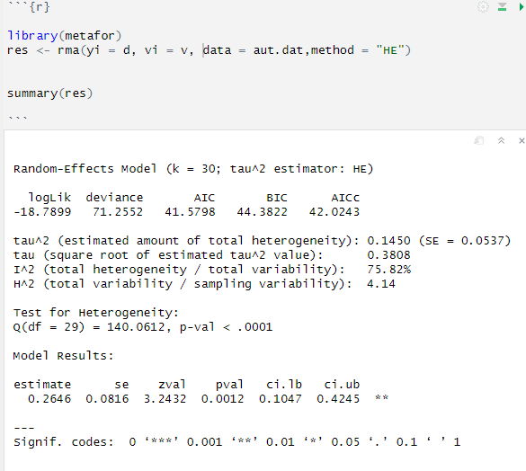

**Figure 4. Summary meta-regression findings using Hedges estimator assume no moderators were considered.**

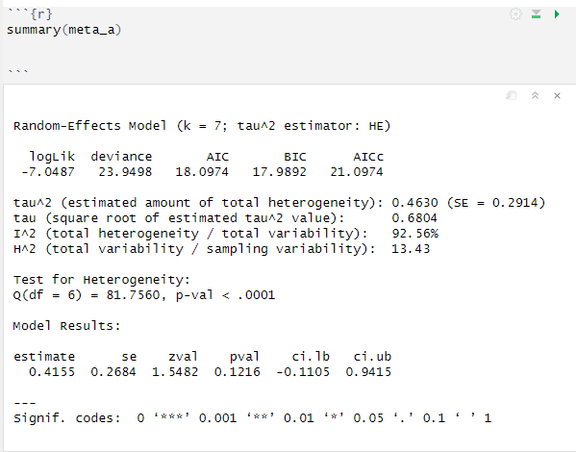

**Figure 4A. Summary meta-regression findings on Type (A) moderator using Hedges estimator.**

For meta-regression (B) we found significant evidence for a change in the true average SMD going from ‘low’ to ‘high’ for neurotypical controls were effective than autistic adults on average (est. SMD change = 0.2646 *(Full Model in Figure 4)*- 0.2522 *(estimator from Figure 4B)* = 0.0124, 95% CI = [0.0529, 0.4515], p = 0.0131). Significant residual heterogeneity was detected at the 5% level (Q = 22.6707, p = 0.0197, I^2 = 52.79%). For (C) we found significant evidence for a change in the true SMD (est. SMD change = 0.2646 *(Full Model in Figure 4)*- 0.1411 *(estimator from Figure 4C)* = 0.1235, 95% CI = [-0.0552, 0.3374], p = 0.1590). There is significant evidence of residual heterogeneity was detected (Q = 24.2420, p = 0.0070, I^2 = 55.30%).

**Figure 4B. Summary meta-regression findings on Type (B) moderator using Hedges estimator.**

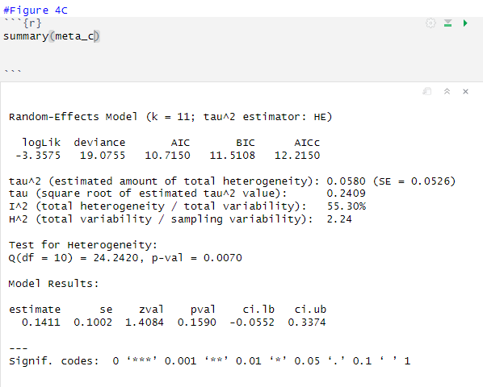

**Figure 4C. Summary meta-regression findings on Type (C) moderator using Hedges estimator.**

**Conclusion**

We were able to replicate partially of the essential results for the meta-analysis. Our additional investigations evidence in favour from the authors conclusion regarding middle-aged autistic adults have a steady decline in cognitive control similarly compared to neurotypical behaviour due to aging. According to the paper is unable to find evidence to suggest neurotypical controls had better performance than autistic adults in all categories. While we support the authors’ conclusions, we caution that statements about the mean SMD should generally not be applied to study-level SMDs. Furthermore, meta-regressions typically suffer from a high risk of confounding, due to small sample sizes and the fact that the data does not form a controlled sample. These facts suggest that we interpret any indicators of causality**.** The results hints for informative designs for future observations through extensive research and evidence are concise enough to support the authors claim.

**References**

* [1] Wang, J., Christensen, D., Coombes, S., & When, Z. (2024, July 4). Cognitive and brain morphological deviations in middle-to-old aged autistic adults: A systematic review and meta-analysis. ScienceDirect. <https://www.sciencedirect.com/science/article/pii/S0149763424002513?ref=pdf_download&fr=RR-2&rr=8dc3ce496a882eb2#bib75>
* [2] Wang, Z. (2024, February 27). Cognitive and brain morphological deviations in middle-to-old aged autistic adults: A systematic review and meta-analysis: Appendix A. Supplementary Material. ScienceDirect. <https://www.sciencedirect.com/science/article/pii/S0149763424002513?ref=pdf_download&fr=RR-2&rr=8de3d3a84ad62e94>
* [3] Higgins, J. P., & Thompson, S. G. (2002, May 21). Quantifying heterogeneity in a meta-analysis. Wiley Online Library. <https://onlinelibrary.wiley.com/doi/10.1002/sim.1186>
* [4] DataCamp. (n.d.). rma.uni: Meta-Analysis via Linear (Mixed-Effects) Models. <https://www.rdocumentation.org/packages/metafor/versions/2.4-0/topics/rma.uni>
* [5]Nordmann, A. J., Kasenda, B., & Briel, M. (n.d.). Meta-analyses: What they can and cannot do. Swiss Medical Weekly. <https://smw.ch/index.php/smw/article/download/1434/1753?inline=1>